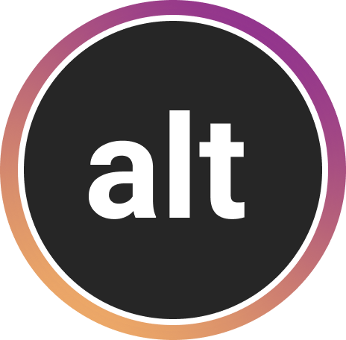

**ALTogether**

*Creating richer, more reliable alt text*

CS 147 Winter 2021

Haeli Baek, Danielle Cruz, Jung-Won Ha, Sydney Jones

March 19, 2021

**Introduction**

**Value Proposition**

Creating richer, more reliable alt text

**Mission Statement**

Our goal is to increase overall awareness about accessibility needs for the visually-impaired by guiding individuals to share accessible content on Instagram.

**Problem / Solution Overview**

Blind and visually impaired users often feel frustrated with the lack of focus, context, and emotion in auto-generated alt text on Instagram. ALTogether brings alt text to the forefront, by educating users on how to write quality alt text, providing auto-generated alt text suggestions that users can easily modify and personalize before posting, and encouraging sighted users to not only adopt alt text practices, but also motivate their friends to do the same.

**ALTogether Team**

|  |  |  |  |
| --- | --- | --- | --- |
| Haeli B. | Danielle C. | Jung-Won H. | Sydney J. |

**Table of Content**

**Needfinding Interviews** **4**

Interviewees 4

Key Findings 4

Empathy Map 5

**POVs & Experience Prototypes** **7**

Final POVs and HMWs 7

Experience Prototypes 8

**Design Evolution** **9**

Final Solution 9

Tasks 9

Low-Fi Prototype 11

Sketches 11

Prototype 13

Major Design Changes: Low-Fi to Med-Fi 15

1. Auto-generate an editable alt text template 16

2. Consolidate alt text prompts onto one page 17

3. Merge alt text indicators into one icon 17

Medium-Fi Prototype 19

Major Design Changes: Med-Fi to High-Fi 21

0. Medium-fi limitations 21

1. Checking alt text for trust and safety 21

2. Identifying personal photos without alt text 22

3. Flexibility in adding / editing alt text 23

4. Clarity of new symbols and concepts 25

High-Fi Prototype 27

**Final Prototype Implementation** **30**

Tools 30

Wizard of Oz Techniques 30

Hard-Coded Data 31

**Summary & Next Steps** **31**

# 

# Needfinding Interviews

## Interviewees

1. **Adrian:** Stanford CS graduate and software engineer, with nystagmus in one eye and blind in the other. He had ample experience with assistive technologies.
2. **Michael:** Stanford lecturer in CS who is visually impaired due to being born with glaucoma. He gave the perspective of a developer and engineer.
3. **Patricia:** A 79 year old woman who experienced gradual vision loss due to age. She gave us the perspective of an elderly person with a non-technical background.
4. **Cricket:** Visually-impaired Stanford undergrad who is a disability equal access advocate. She shared how inaccessible images are due to lack of alt text.
5. **Robin:** Works with academic education materials (usually document based) and assistive technologies at Stanford’s Office of Accessible Education.
6. **Erin:** Works at LightHouse Labs, a center for blind and low-vision fold in San Francisco, where tech innovators collaborate with blind engineers, scientists, power users and advocates.

## Key Findings

There was a common desire for improved accessible technologies to have independence and autonomy over actions. We found that this can lead to the strengthening of social bonds and rapport across a range of everyday contexts — everything from not accidentally bumping into strangers, or understanding somebody’s life better through the alt text on their social media pictures. Most importantly, we found that increased awareness of accessibility needs among sighted users directly contributes to a more conscious effort to produce and output accessible content.

## Empathy Map

Adrian (Figure 1)

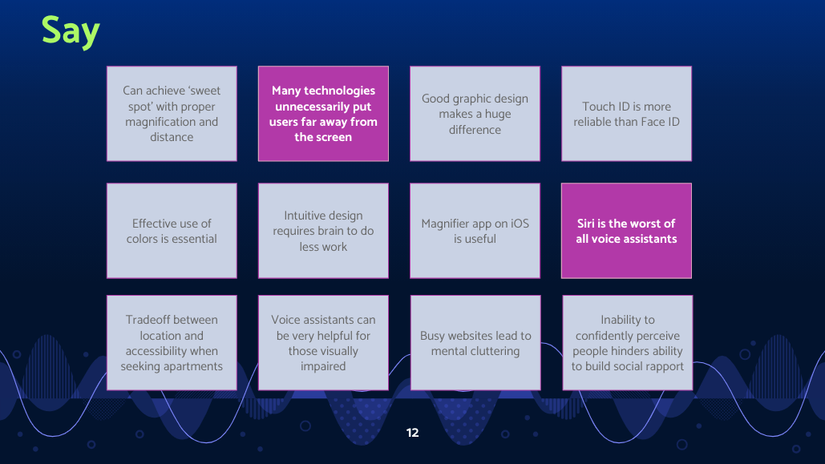

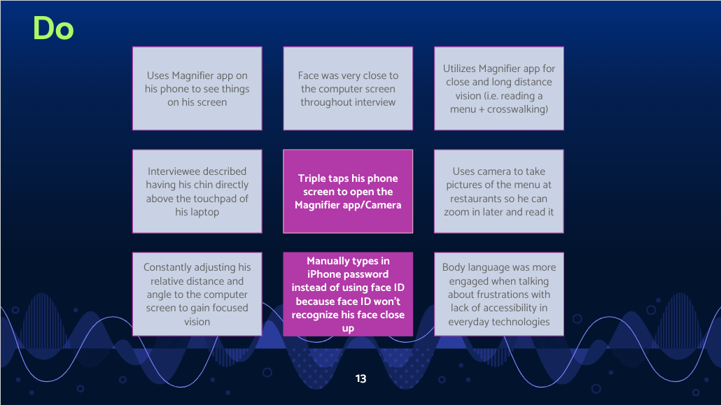

**Empathy Map (cont’d)**

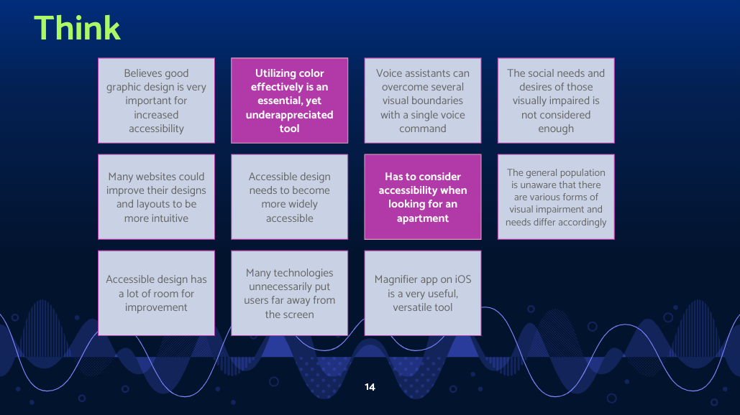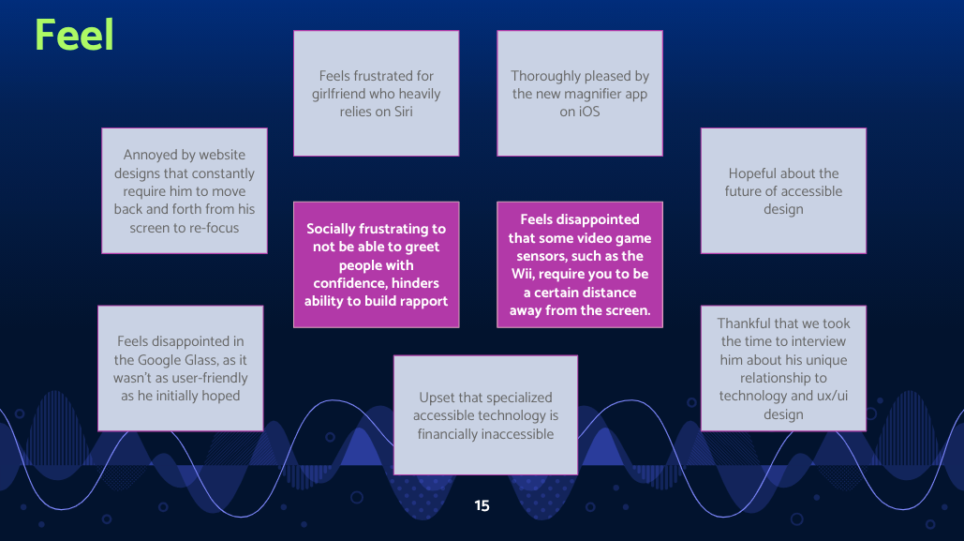

# POVs & Experience Prototypes

## Final POVs and HMWs

**POV #1.** We met Cricket, a Stanford student who is fully blind and a strong advocate for improved accessibility for those visually-impaired. We were amazed to realize how frustrating it is to interact with images and PDFs without alt text because they are virtually inaccessible to her without the help of someone else. It would be game-changing to empower visually impaired users to interact with images in a more reliable way without the need for others’ help.

* HMW...make alt text easier to implement into all images?
* HMW… make it easier for visually-impaired people to interact with text in images and PDFs?

**POV #2.** We met Adrian, a visually-impaired software engineer and Stanford CS grad with nystagmus in one eye and blindness in the other. We were amazed to realize not being able to detect the presence of others makes it hard to engage socially and build rapport. It would be game-changing to provide a better way to detect the presence and identity of others in the same vicinity without having to visually see them.

* HMW… help facilitate smoother greetings between visually-impaired people and others?
* HMW… remove the need to rely on vision to detect who is in the room?

**POV #3.** We met Adrian, a visually-impaired software engineer and Stanford CS grad whow is in the process of moving to Vancouver. We were amazed to realize that he has to consider many aspects of accessibility when looking for a new apartment, and that the most centrally-located apartments are also often the least accessible. It would be game-changing to help visually-impaired people find accessible apartments in a convenient way.

* HMW…help visually impaired people quickly find out if an apartment has their desired accessibility features?
* HMW… help visually impaired people experience a new space before actually visiting it physically?

**Potential Solutions**

1. An extension with automatic prompts that require sighted users to attach alt text to any images that you send or upload
2. Personalized, smart vibrations that notify visually-impaired people when someone is waving at them or is in their vicinity through smartphones and location tracking
3. Have an online community where visually-impaired people can write reviews and rank accessibility based on their personal experiences

## Experience Prototypes

To test the merits and assumptions behind each of our potential solutions, we conducted experience prototypes with both blind / visually-impaired and sighted users.

1. **Image Interaction.** We prompted Isabelle, a sighted user, to write an alt text for a few images she had posted on social media.
   1. Assumption: People know what alt text is and how to write them for their images.
   2. Results: Isabelle had no experience writing alt text. The inexperience led her to feel a lot of hesitation and uncertainty and it showed in the way she focused solely on the literal contents of the photo (without regard to best practices) rather than also including the context or emotions.
2. **Smart Vibrations.** We asked Steve, who is visually-impaired, to assign custom vibrations for our two interviewers. Then, each interviewer took turns texting Steve and seeing if he could determine who was texting him based on the vibration patterns.
   1. Assumption: Visually-impaired users can distinguish different vibration patterns to identify different people entering a room.
   2. Results: Distinguishing between several different vibration patterns was rather challenging even with conscious effort.
3. **Yelp for Accessible Buildings.** We created two different reviews for the same coffee shop: one containing a standard list of accessibility features, and the other containing personal reviews from visually-impaired people who had previously visited the shop. We observed which review Trisha, who is blind, would prefer.
   1. Assumption: Visually-impaired users will feel more comfortable trusting personal reviews rather than a list of features.
   2. Results: Trisha preferred personal reviews over a generic list of features because everybody’s experience with visual impairment is very different. Hearing about someone else’s positive experiences better helped her predict what her experience at this space might be like.

# Design Evolution

## Final Solution

Based on what we learned in the experience prototypes, we decided to focus on the problem of image inaccessibility due to the pervasive issue of inaccurate and unreliable alt text, which we encountered across several of our needfinding interviews.

We realized that zeroing in on alt text and making interacting with images more accessible would also address some of our other goals of facilitating better social rapport for blind and visually-impaired people via digital connections and online inclusion. Ultimately, we realized that the challenge of accessibility isn’t a person’s disability, but rather how technology isn’t designed in a way that’s accessible to them. Thus, we wanted to focus our efforts toward a solution that would make these technologies more accessible from the start: from the moment of posting.

## Tasks

To achieve this solution, we outlined the following three tasks:

**Simple Task.** Sighted users are reminded to write alt text and can find where to write it in the first place.

Through our interviews and experience prototypes, we found that one of the greatest barriers to reliable alt text is a general lack of awareness amongst sighted users. Many sighted users we talked to didn’t know what alt text was or that there’s even an option to add alt text to all of your photos. As Instagram stands now, the only way to add alt text to your post is to find it buried several clicks down in advanced settings. Thus, we wanted to bring alt text to the forefront and embed it as a regular part of the posting process. This way, sighted users wouldn’t accidentally forget or overlook writing alt text, just like they wouldn’t forget to write a caption or add a filter.

**Moderate Task.** Sighted users can identify which photos lack alt text and encourage friends to add their own alt texts.

In line with this idea of lack of awareness, we also realized that only people who know what alt text is would realize that they should write it. In some of our needfinding interviews, blind users expressed that they thought that if sighted users had a bit of a nudge to write alt text, they would be more likely to include it. Thus, we wanted to incorporate some sort of social incentive into our tasks such that people would feel more motivated to write alt text, on top of generally making their content more accessible to visually-impaired users. With system notifications often clouding a user’s feed, we decided that social-based notifications would be more effective since they would come directly from one of the user's followers. Additionally, facilitating social incentives helps with increasing awareness about alt text and its importance more broadly.

**Complex Task**

Sighted users modify auto-generated alt text suggestions to add personalized context to their images.

As we learned more about how alt text is attached to photos, we found that even though Instagram auto-generates alt text to your images, they can often be quite inadequate descriptions that lack context and nuance. Even worse, they can often be completely inaccurate to begin with. As a result, we wanted to provide the option for users to easily edit the auto-generated alt text suggestions that image detection software can provide in order to make them more accurate and representative of what is in the image.

## Low-Fi Prototype

### Sketches

After settling on our final solution, we sketched different possible realizations of our design. These ideas included a camera extension that auto-generates alt text suggestions in real time; a mobile app where you could receive alt text writing tips and track your progress in writing alt text; and even an iOS extension that automatically prompts you to add alt text to all your photos (Figures 2, 3, and 4 respectively).

|  |
| --- |
|  |
| **Figure 2**. Camera extension that auto-generates alt text suggestions as you point your camera at different objects in real time. |

|  |
| --- |
|  |
| **Figure 3.** Separate mobile app where you can go for alt text writing tips before uploading to Instagram or Facebook. Sync with your social media to track accessibility progress. |

|  |
| --- |
|  |
| **Figure 4.** iOS extension that detects whenever you’re uploading an image and automatically prompts you to add alt text no matter what app or social media platform you’re on. |

We decided to move forward with an Instagram extension that’s embedded into the app and integrates alt text reminders into learned and familiar Instagram interactions. Since Instagram is a photo sharing app, it’s crucial that blind and visually-impaired users are still able to access the images their friends post on the platform. Our solution, ALTogether, is a native solution on Instagram that educates users on how to write quality alt text, provides auto-generated alt text suggestions that users can easily modify and personalize before posting, and increases awareness on what alt text is and why it is so important.

### Prototype

After sketching storyboards on paper, we uploaded screenshots to [POP](https://marvelapp.com/pop) so that users could interact with the prototype on their own devices (Figures 5-8). The prototype simulates an easier alt text writing experience within the current Instagram UI supplemented by features defined for our 3 main tasks.

|  |
| --- |
|  |
| **Figure 5.** Simple Task: Sighted users are reminded to write alt text and can find where to write it in the first place. |

|  |
| --- |
|  |
| **Figure 6.** Moderate Task: Sighted users identify which photos lack alt text and encourage friends to add their own personalized alt texts. |

|  |
| --- |
|  |
| **Figure 7.** Complex Task: Sighted users modify auto-generated alt text suggestions to add personalized context to their images. |

|  |
| --- |
|  |
| **Figure 8.** All screens of our low-fi prototype including interactive buttons and pull up screens. |

## Major Design Changes: Low-Fi to Med-Fi

We tested our low-fi prototype with three participants who had varying degrees of familiarity with using Instagram:

* **Nina, 23.** Dental student who we considered to be a “common user” of Instagram.
* **Afreen, 25.** Instagram influencer who we considered to be a “power user.”
* **Aimee, 55.** A business owner who we considered to be an “older user” with less Instagram familiarity.

Through our observations, we were able to uncover misguided design choices and validate many of the assumptions we made in our prototype. Below are a few of the most major design changes that resulted from our low-fi experiment findings.

### 1. Auto-generate an editable alt text template

We initially modeled the ALTogether alt text fields after Instagram’s existing caption fields when posting an image, so we included empty text boxes where the user could compose their alt text completely from scratch. Our intention was that the user would generate full sentences in response to different prompts, and their individual answers would be consolidated into a complete alt text. However, this alt text writing process was so embedded in the regular posting flow that many users confused these prompts with suggestions for writing regular captions on their images. Additionally, many users felt it was too much work to type out full sentences for multiple prompts, as it made them less likely to take the time to write out quality responses.

We revised our guided alt text process to begin by auto-generating a suggested alt text and having the user edit it with more detailed, more accurate context (Figure 9). Suggestions appear in small bubbles where the user can click and write replacements for incomplete or incorrect suggestions. This way, users can still correct and personalize their alt texts without having to start completely from scratch, reducing the amount of time and effort they would need to invest into writing a quality description.

|  |  |
| --- | --- |
| **Before** | **After** |
|  |  |
| **Figure 9.** Low-Fi vs. Med-Fi: Alt text suggestions | |

### 2. Consolidate alt text prompts onto one page

In our low-fi prototype, we’d initially designed the alt text prompts to span multiple pages with each containing a different alt text prompt. We confirmed that users appreciated these scaffolded prompts, as they liked how it broke down the unfamiliar process of writing alt text into more manageable chunks. However, in all 3 of our interviews, the user clicked through these prompts too quickly, consequently missing a few key details about what the prompt was asking. Many users also found it overwhelming to answer prompt after prompt since it posed too much text to read all at once. As a result, we decided to consolidate the entire alt text writing process into a single screen, so that users must more intentionally interact with the prompts rather than mindlessly click through them (Figure 10).

|  |  |
| --- | --- |
| **Before** | **After** |
|  |  |
| **Figure 10.** Low-Fi vs. Med-Fi: Alt text prompts on multiple pages vs. a single page | |

### 3. Merge alt text indicators into one icon

In our low-fi designs, we had two separate icons to indicate whether an image a user encountered had alt text:

1. A ✓ or ✖️ at the top-right corner of each post indicating whether it has alt text.
2. An “alt” icon at the bottom-left corner of each post, which the user can click to see the image’s associated alt text. If the image lacks alt text, a button would appear to “nudge” the original poster to write one.

We decided to split these icons into two because we wanted a way for users to quickly identify if an image had alt text without having to first click the alt text icon to see it. However, many users were confused about what the ✓/✖️ meant, not realizing that it related to alt text at all. For instance, some users thought it might mean that the poster was a verified celebrity or that you had liked the image.

Thus, we decided to combine these two symbols into a single alt text icon (Figure 11). Because users had found the ✓/✖️ and the “alt” icon so unrelated, we applied Gestalt principles to group these elements together. Rather than have a completely separate symbol on the opposite side of the post, this new “alt” icon merges both functions and uses a colored outline to indicate if the image includes alt text. This way, users can still quickly identify which images are accessible upon first glance. Additionally, the colored outline recalls the familiar action of tapping on “IG stories,” suggesting that the user can click on the icon for additional interactions like nudging.

|  |  |
| --- | --- |
| **Before** | **After** |
|  |  |
| **Figure 11.** Low-Fi vs. Med-Fi: Alt text indicators | |

These major changes helped to inform our design revisions for the medium-fi prototype moving forward.

## Medium-Fi Prototype

**Simple Task.** Users are reminded to write alt text and can find where to write it in the first place (Figure 12).

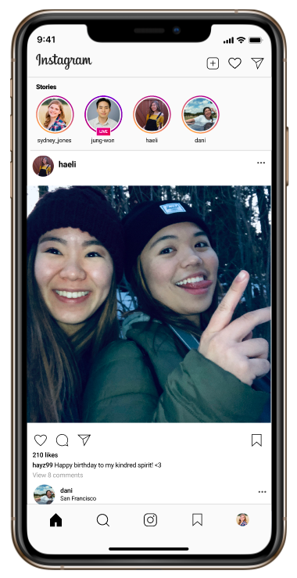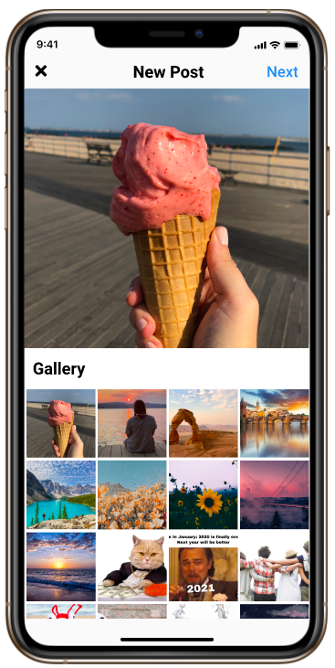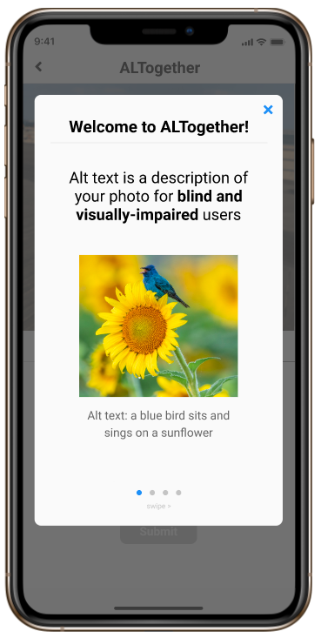

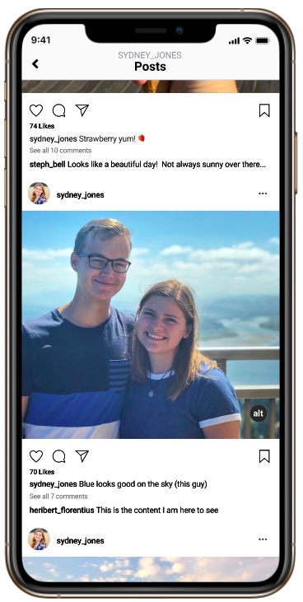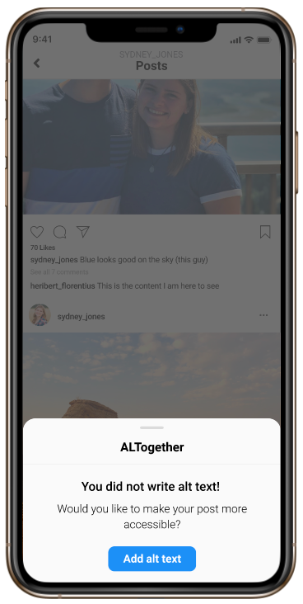

**Moderate Task.** Users identify which photos lack alt text and encourage (“nudge”) friends to add their own personalized alt texts (Figure 13).

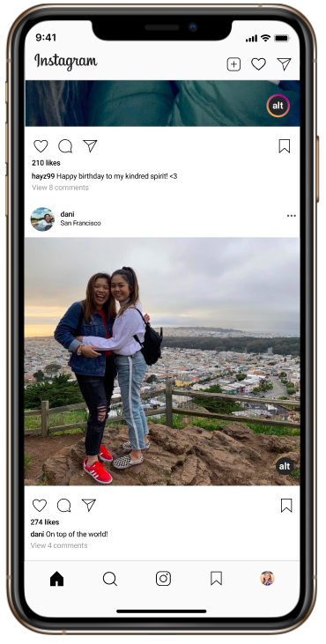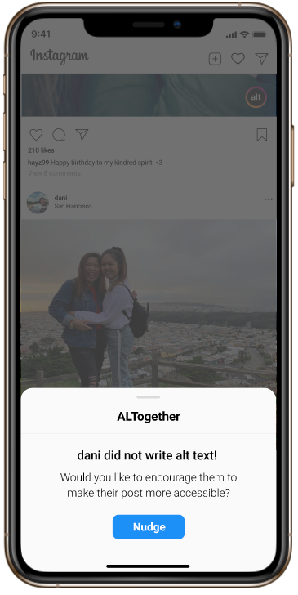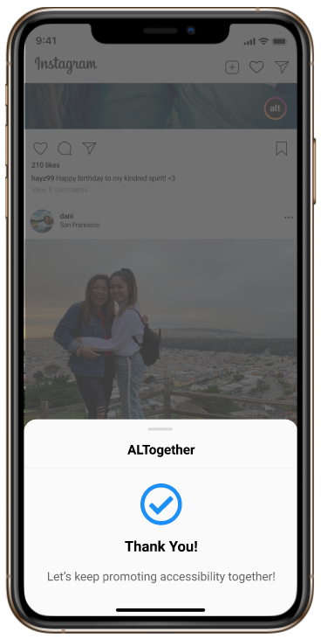

**Complex Task.** Users modify auto-generated alt text suggestions to add personalized context (Figure 14).

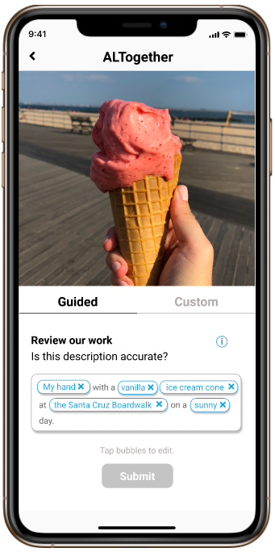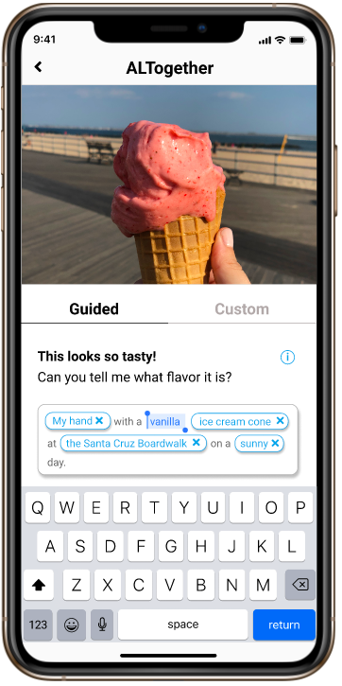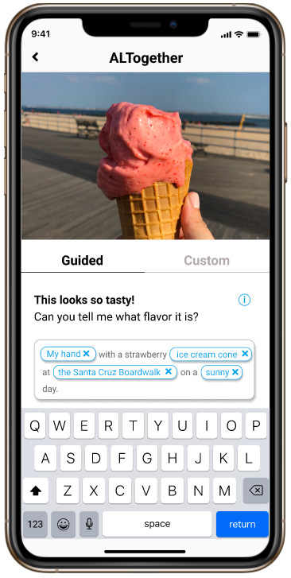

## Major Design Changes: Med-Fi to High-Fi

Our major design changes from the medium-fi prototype to the high-fi one all came from addressing the violations flagged in our heuristic evaluations. We sifted through all of the feedback from our peers’ findings and sorted them by severity and grouped them by category, as several violations often narrowed in on the same issue. We addressed all 14 major severity 3-4 violations and addressed a handful of other minor severity 1-2 violations as well. Below is a summary of the heuristic violations that we addressed along with our proposed solutions.

### 0. Medium-fi limitations

**Violations.** These issues originated in the limitations that we experienced in using Figma as a design tool since creating differen flows to account for a wide range of user options often meant having to design a separate Figma frame for each possible user pathway.

* H1. Before writing alt text for your own photo, there is no way to see others’ alt texts (Severity: 3)
* H3. No way to go to home screen without filling out alt text screen (Severity: 4)
* H4. No way to swipe right in the onboarding sequence (Severity: 4)
* H6. After switching screens, all the user’s work and changes to the alt text are gone (Severity: 3)
* H7. Onboarding sequence continues to show up even after the first pass (Severity: 3)

**Fix.** These violations were resolved in our high-fi prototype since we could use code and logic to map out the flow of screens deterministically. With code, we could also use variables and object properties to keep track of user work, such that onboarding screens only pop up on the user’s first visit. Additionally, we could store strings to maintain user’s edits to alt text even after they leave specific screens.

### 1. Checking alt text for trust and safety

**Violations.** These issues addressed error checking and trust and safety checking on submitted alt texts. Since we’re asking users to take another step to add alt text when posting an image, they may just rush through the process of typing one out, potentially leading to problematic typos or gibberish alt texts.

* H5. There may be typos, especially in the custom alt text, that may hinder screen readers (Severity: 3)
* H5. Users could put gibberish language, or other hard-to-understand content to try and speed through the mandatory submission. (Severity: 3)

**Fix.** Add a text to speech feature that reads alt text like a screen reader would (Figure 15). This way, users can quickly get a sense of how their alt text would appear to blind users who use a screen reader. Additionally, they can hear if there are typos or if the wording of their alt text doesn’t make sense.

|  |
| --- |
| Before After |
| **Figure 15.** Med-Fi vs. High-Fi: Text to speech redesign |

### 2. Identifying personal photos without alt text

**Violations.** These violations addressed issues when identifying which of your own photos lack alt text. For others’ images which lack alt text, we’d already built in the ability to nudge the original poster; for your own images, we’d only built a progress bar to track the number of personal photos without alt text. However, this progress bar didn’t indicate which ones lacked alt text specifically. For a uers with hundreds or even thousands of posts, hunting for the photos without alt text would prove immensely difficult and likely disincentivizing.

* H7. The user has to hunt for photos which don’t include alt text (Severity: 3)
* H9. An influencer may have hundreds, if not thousands of photos - they may be disincentivized to dig through which photos do or don’t have alt text. (Severity: 2)

**Fix.** Add “alt view” on profile to see only images which lack alt text (Figure 16). In the same way that users can easily see the photos they were tagged in by clicking on an icon on their profile, they will be able to click on an alt icon that displays all the photos that need alt text, thus removing any hassle and confusion.

|  |
| --- |
|  |
| **Figure 16.** Med-Fi vs. High-Fi: Added “Alt view” to see only personal images which lack alt text. |

### 3. Flexibility in adding / editing alt text

**Violations.** These issues revolved around user freedom and flexibility when adding and editing alt text. After a user posted a photo with alt text, they did not have the freedom to go back and edit that alt text later on. There was also no way to accept the auto-generated suggestions without first editing them. In the case that the auto-generated suggestion was already accurate and required no corrections, this lack of flexibility would likely frustrate the user.

* H3. After the user adds alt text to their photo, it’s impossible to change it (Severity: 3)
* H4. The “Submit” button is greyed out until you change the suggested alt text, but users may want to keep the very first alt text generated by ALTogether (Severity: 2)

**Fix.** Add an “edit” button in the same popup that shows the alt text for your photo. Additionally, make the “Next” button clickable right away. Instead of incentivizing users to edit corrections by first making the “Next” button unclickable, automatically focus the screen on the text input such that the keyboard pops up without any additional clicks (Figure 17).

|  |
| --- |
| Before    After |
| **Figure 17.** Med-Fi vs. High-Fi: Incorporated more user flexibility into adding and editing alt text on personal photos. |

### 4. Clarity of new symbols and concepts

**Violations.** These issues were regarding the clarity of new concepts which ALTogether introduced, like the “alt” symbol and nudging — that is, where nudges go and how you can tell when you’ve been nudged. There was also confusion about what the blue, editable bubbles on the alt text screen meant and whether you could only edit them once or repeatedly.

* H3. It’s unclear what the outline or lack of outline around the “alt” logo displayed on pictures means (Severity: 3)
* H3. There are no places that indicate whether you have a nudge or not (Severity: 3)
* H4. The blue alt text “bubbles” only seem to be editable onces since the “x” disappears, signaling a more permanent change (Severity: 3)

**Fix.** Embed introductions to new concepts within icons (Figure 18). We decided to embed mini moments of onboarding into familiar instagram UI, such as showing a “view alt text” button the first time users are introduced to the alt button on their photos. Additionally, we added nudges to appear within the notifications page to show the user when they have been nudged. We also changed editable text from bubbles to dashed underlined text so it’s clearer that the user can change the text as many times as they want.

|  |
| --- |
|  |
| **Figure 18.** Med-Fi vs. High-Fi: Redesigned icons to introduce users to new concepts. |

## High-Fi Prototype

**Simple Task (Figure 19).**

|  |
| --- |
|  |
| **Figure 19.** Simple Task: Sighted users are reminded to write alt text and can find where to write it |

**Simple Task, extended (Figure 20).**

|  |
| --- |
|  |
| **Figure 20.** Simple Task, extended. |

**Moderate Task (Figure 21).**

|  |
| --- |
|  |
| **Figure 21.** Moderate Task: Sighted users identify which photos lack alt text and encourage friends to add their own personalized alt texts. |

**Complex Task (Figure 22).**

|  |
| --- |
|  |
| **Figure 22.** Complex Task: Sighted users modify auto-generated alt text suggestions to add personalized context to their images. |

# Final Prototype Implementation

## Tools

For our high-fidelity prototype implementation, we used Figma, React Native, Expo, and Xcode.

* **Figma.** Figma was helpful in planning the layout and visuals of our prototype before coding the high-fidelity version. However, Figma did have some limitations in certain aspects, such as in transitions between screens and a lack of key features in our prototype, such as the text to speech feature.
* **React Native.** We used React Native to develop and build the prototype. React Native has a plethora of helpful modules and libraries that we used, such as Stack Navigator, which helped to transition between screens in our app. The nature of React Native also allowed us to easily reuse components after building them. For example, in our “Instagram” feed, we were able to reuse card components and simply replace the pictures and users attached to them to stitch together a scrollable feed.
* **Expo and Xcode.** For simulating and testing our application, we used Expo and Xcode’s iOS simulator. This allowed us to see what our app looks like on a real iPhone 12 Pro Max. More importantly, it helped us test the interactions on the app to make sure the functionality was working properly. We were also able to use the expo-speech library to implement the text to speech feature on our application.

## Wizard of Oz Techniques

**AI and image detection software.** When the user goes to the alt text editing page, there is an auto-generated alt text suggestion for the image that is about to be posted. This gives the illusion that our app is able to detect certain key features of an image (e.g. the number of people, the actions being taken, the location, etc.) to generate editable alt text captions. However, in reality, these “auto-generated” captions are hardcoded.

**Nudging other users.** Additionally, when a user discovers a post without alt text and decides to “nudge” the original poster, the user is made to believe that an actual message from ALTogether is sent to that person due to the pop-up confirmation that tells the user that their nudge was sent.

**Tracking Progress.** Lastly, when a user goes to their profile, there is a progress bar that tracks how many of their posts include alt text. This makes it appear like ALTogether has access to the Instagram API to be able to detect whether or not a particular image has alt text, which is currently not the case.

## Hard-Coded Data

**Auto-generated alt text suggestions.** We had to rely on a lot of hard-coded data to implement our final prototype. Specifically, every image in our database had a predetermined alt text caption to act as the “auto-generated” alt text suggestion that ALTogether provides when adding alt text to a photo.

**Feed Content.** All the user profiles and posts on the feed were also hard-coded, including the captions, likes, and comments for each photo.

# Summary & Next Steps

Images play such a huge role on social media platforms; however, the notion of alt text is unknown to many sighted users, hence leaving countless photos without alt text descriptions. This exclusion of alt text leaves images on Instagram virtually inaccessible to blind or visually-impaired users who rely on screen readers to navigate the digital landscape. Not only do most images on social media platforms lack alt text, but those that do often use auto-generated ones that tend to be inaccurate and lacking in the context and nuance only a human can provide. We also learned that social media platforms often have a convoluted, hidden process for adding personalized alt text, resulting in sighted users not knowing how to add alt text even if they wanted to be allies. Through the quarter-long process of needfinding, testing, designing, and prototyping, we created a high-fidelity prototype of ALTogether to address these issues on Instagram specifically. We designed a version of Instagram that brings alt text to the forefront by seamlessly integrating the alt text writing process into the regular flow of posting a photo, making alt text (or the lack thereof) visible on all posts, and increasing awareness on what alt text is and why it plays such an important role in accessibility. Our team had an amazing experience creating ALTogether and appreciated all the feedback and guidance we received along the way. In the future, we would love to expand the nudge feature to create a supportive community on Instagram regarding image accessibility. One such idea that we never got to implement was a “high-five” feature that a nudger could send if a user added alt text after receiving their nudge. We would also love to expand ALTogether so that it works on other social media platforms beyond Instagram!